Министерство образования и науки РД
ГБПОУ РД «Колледж машиностроения и сервиса им. С. Орджоникидзе»

Методическая разработка внеклассного мероприятия по английскому языку на тему:
«The English and American Literature»

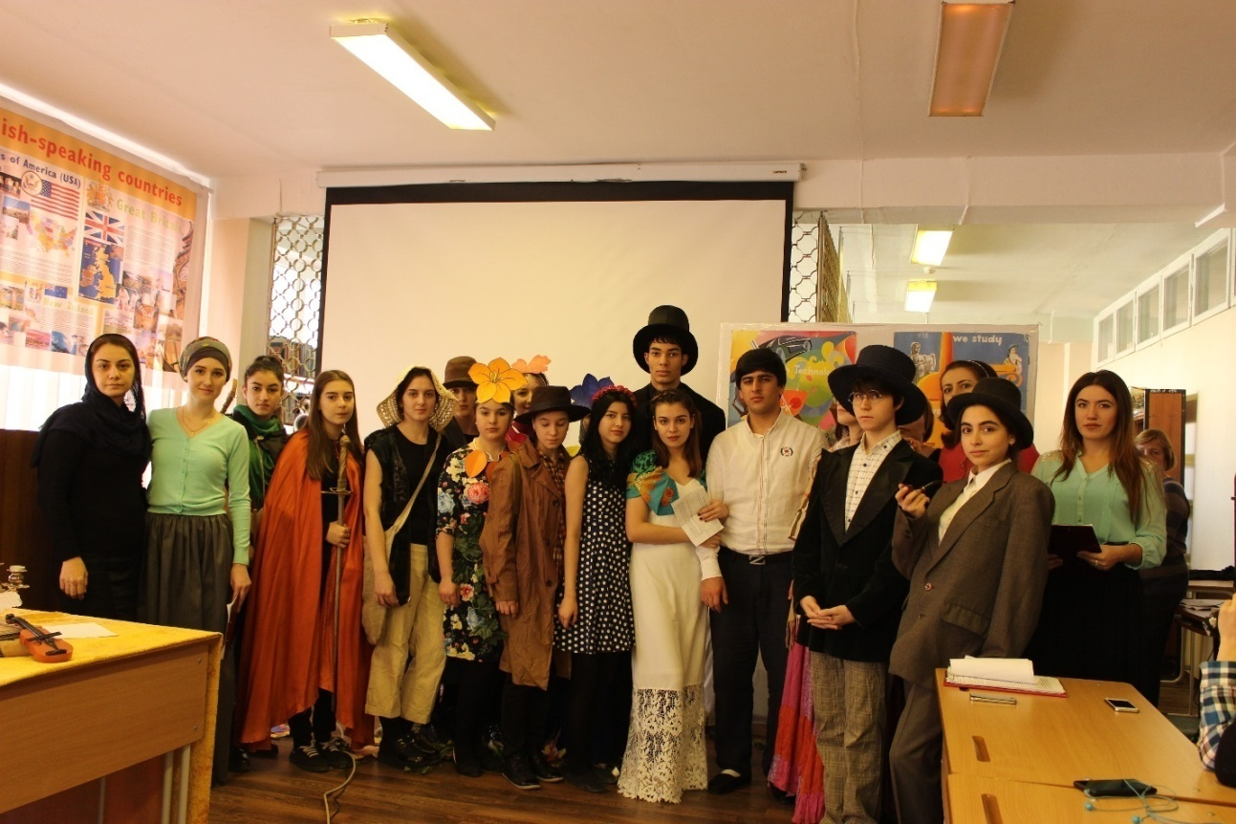

г. Каспийск

Содержание

1.Введение 2
2.Цели мероприятия 3
3. План мероприятия 4
4. Ход мероприятия 5
4.1.Вступительное слово преподавателя 5
4.2.Представление литературных персонажей 7
4.3.Сценка «Клуб литературных героев» 7
4.4.Сценка из произведения «Алиса в стране чудес» 10
4.5.Сценка из произведения «Мартин Иден» 13
4.6.Сценка из произведения «Белый клык» 14
4.7.Жизнь и творчество У.Шекспира 14
4.8.Краткое содержание пьесы У.Шекспира «Ромео и Джульетта» 15
4.9.Сценка из произведения «Ромео и Джульетта» 16
4.10.Жизнь и творчество Р.Бернса 17
4.11.Стихотворение «В горах мое сердце» 17
4.12.Стихотворение «Любовь, как роза красная» 18
4.13.Жизнь и творчество М.Твена 19
4.14.Сценки из произведения М.Твена «Том Сойер» 20
4.15.Жизнь и творчество Д.Г.Байрона 23
4.16.Стихотворение «Природа-мать» 23
4.17.Стихотворение «Моя муза» 24
4.18.Жизнь и творчество Т.Мура 25
4.19.Стихотворение «Вечерний звон» 26
4.20.Песня «Пусть продолжается шоу!» 26
4.21.Заключительное слово преподавателя 28
5.Список использованной литературы 30

Введение
На современном этапе обучение иностранному языку, осуществляемое не только на уроке, но и во внеурочной деятельности, должно вносить конкретный вклад в формирование гармонично развитой личности. Владение иностранным языком становится инструментом успешной деятельности обучающегося и средством, формирующим личность и способность быть активным участником открытого языкового пространства.
Цель обучения иностранному языку - подготовка к реальной межкультурной коммуникации, обучать страноведению и культуре страны изучаемого языка, т.е. учить узнавать, понимать другие народы посредством языка, в результате чего мы лучше понимаем и себя. Источником знаний, прежде всего, являются литературные произведения авторов страны изучаемого языка, а уже потом коммуникация с носителями языка и культуры. Это подтверждает возрастающая с каждым днем мобильность и открытость общества. Мероприятие посвящено жизни и творчеству великих английских и американских писателей и поэтов 16-18 веков. Именно это и обусловило выбор темы для проведения внеклассного мероприятия «Литературная гостиная», тем более, что год 2015 был объявлен Годом Литературы в России.

Цели мероприятия:
- ознакомить студентов с жизнью и творчеством английских и американских писателей;
- совершенствовать грамматические навыки;
- активизировать работу каждого студента.
-развивать творческую мыслительную деятельность, кругозор, память и внимание у студентов;
-развивать интерес к английской и американской литературе;
-развивать умения воспринимать на слух и понимать краткие сообщения, письменно оформлять информацию по теме «Англо-американская литература».
- развивать лексические навыки говорения;
- воспитать у студентов познавательный интерес к творчеству английских и американских писателей;
- сформировать у студентов уважение и интерес к культуре и народу страны изучаемого языка;
- прививать любовь и желание изучать иностранный язык через разные формы работы;
- формировать у студентов чувство товарищества, навыки межличностного общения, самоконтроля и контроля деятельности других студентов.
Оснащение: интерактивный комплекс, презентация, видеозаписи, выставка книг английских и американских писателей, плакаты с цитатами, выставка иллюстраций к произведениям М.Твена, выполненных студентами, канделябры со свечами, цветы, стенгазеты, фотографии английских и американских писателей, макет Лондона, макеты замков, театральные костюмы.
План мероприятия
I. Вступительная часть
  - Вступительное слово преподавателя
  - Музыкальный видеоролик об Ирландии
II. Основная часть
2.1 Представление литературных персонажей
2.2 Сценка «Клуб литературных героев»
2.3 Сценка из произведения «Алиса в стране чудес»
2.4 Сценка из произведения «Белый клык»
2.5 Сценка из произведения «Мартин Иден»
2.6 Жизнь и творчество У.Шекспира
2.7 Краткое содержание пьесы У.Шекспира «Ромео и Джульетта»
2.8 Сценка из произведения «Ромео и Джульетта»
2.9 Жизнь и творчество Р.Бернса
2.10 Стихотворение «В горах мое сердце»
2.11 Стихотворение «Любовь, как роза красная»
2.12 Жизнь и творчество М.Твена
2.13 Сценки из произведения М.Твена «Том Сойер»
а) Сценка «Том и тетушка Полли»
б) Сценка «Том не хочет идти в школу»
2.14 Жизнь и творчество Д.Г.Байрона
2.15 Стихотворение «Природа-мать»
2.16 Стихотворение «Моя муза»
2.17 Жизнь и творчество Т.Мура
2.18 Стихотворение «Вечерний звон»
2.19 Видеоролик из фильма «В бой идут одни старики»
III.Заключительная часть
3.1. Песня «Пусть продолжается шоу!»
3.2. Заключительное слово преподавателя.
“The English and American Literature”
“Литературная гостиная”
(слайд 1 с приглушенной музыкой)
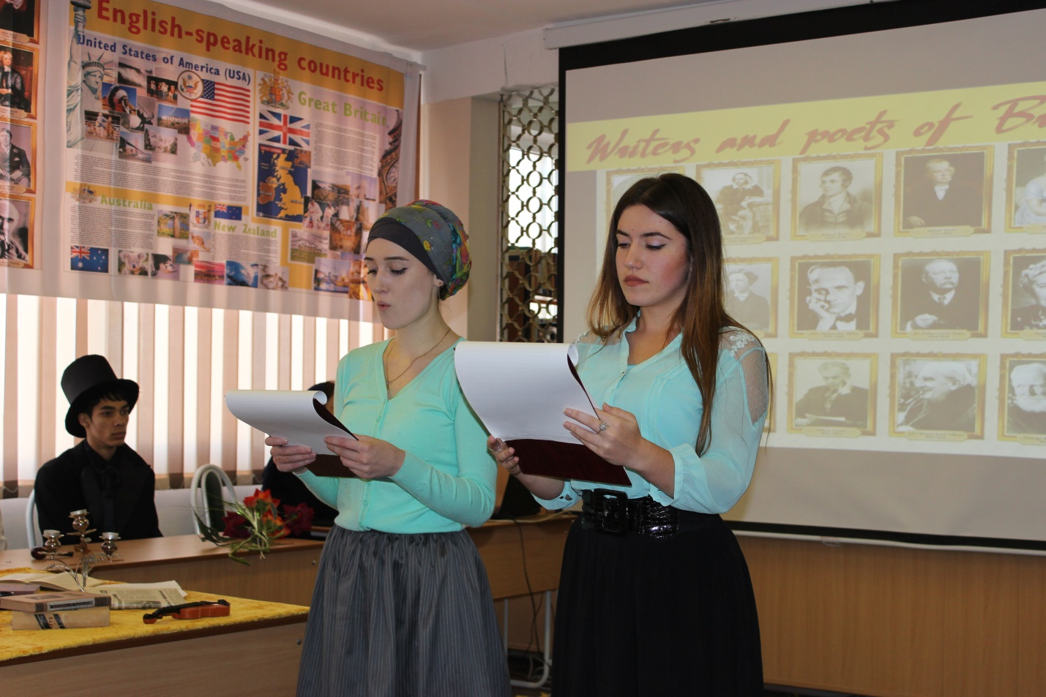
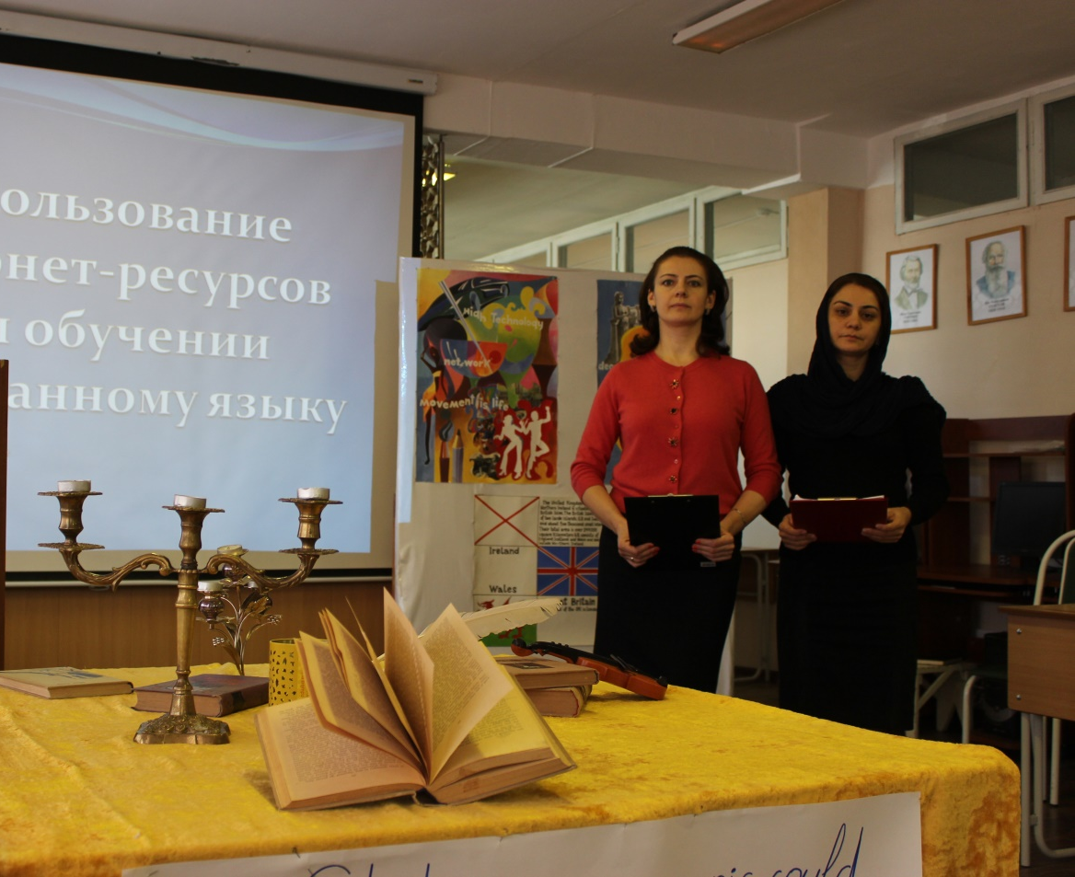
Teacher: Good afternoon, dear guests, members of the teaching staff, students and lovers of the English language. We are really happy to welcome you to our party devoted to the English-American literature.
We hope you are fine today. Allow us to tell you a few words about the aim of our literature party. We want you to dive into the world of both English and American literature and poetry. Every nation has its own culture, its spiritual values, the perception of the world and this is reflected in its language. Poetry introduces students to the culture of learning language and promotes to the assimilation of educational material, and development of language skills. (слайд 2)
Today we are going to talk about W. Shakespeare-one of the greatest writers and poets of the 16th century W. Shakespeare. I think, it’s impossible to speak about English literature without mentioning this author. (слайд3)
We’ll talk about the greatest Scottish poet of the 16th century Robert Burns, and not less famous American writers Mark Twain and Jack London, about a famous English poet – George Byron, an Irish poet and composer of the 18th century Thomas Moore, an outstanding Irish playwriter and critic George Bernard Shaw and others. (слайд 4)
Our students will do their best to demonstrate their acting skills. They are to act out episodes taken from the works of the English and American writers; they will read poems of the greatest poets. Our actors and actresses are nervous, so we request you kindly not to be so critical and forgive their mistakes if such occur.
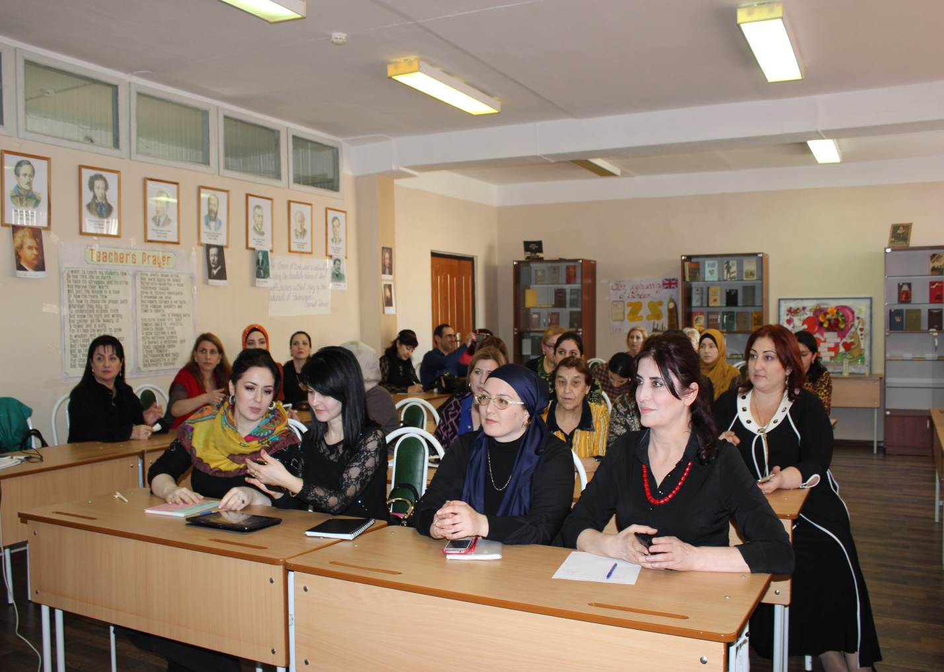

Compere 1: (слайд 5) Dear friends! Today's English Party is devoted to the great English and American writers, whose books are loved by both children and grown-ups all over the world. The names of some writers have become so familiar to you during your school years that very often we mix up whether this an English or an American one. Compere 2: That is why we have asked our students to dramatize any scene from their favorite books. (Pause)
Tom Sawyer: (слайд 6) That's fine we are not late. The president of our "Club of Famous Captains" has sent the main characters of your favourite books to take part in your party. So we are here, look at this people. They'll speak about themselves and you'll soon know who is who. Robin Hood: (слайд 7) Hello! Do you know who I am? I am Robin Hood. Ballads dedicated to me and my merry man were written down at various times but not earlier than the 14th and 15th centuries. I am an outlaw but today I am your guest. Let me introduce my friend Robinson Crusoe to you.
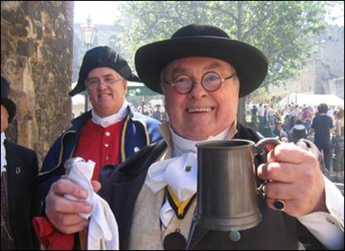
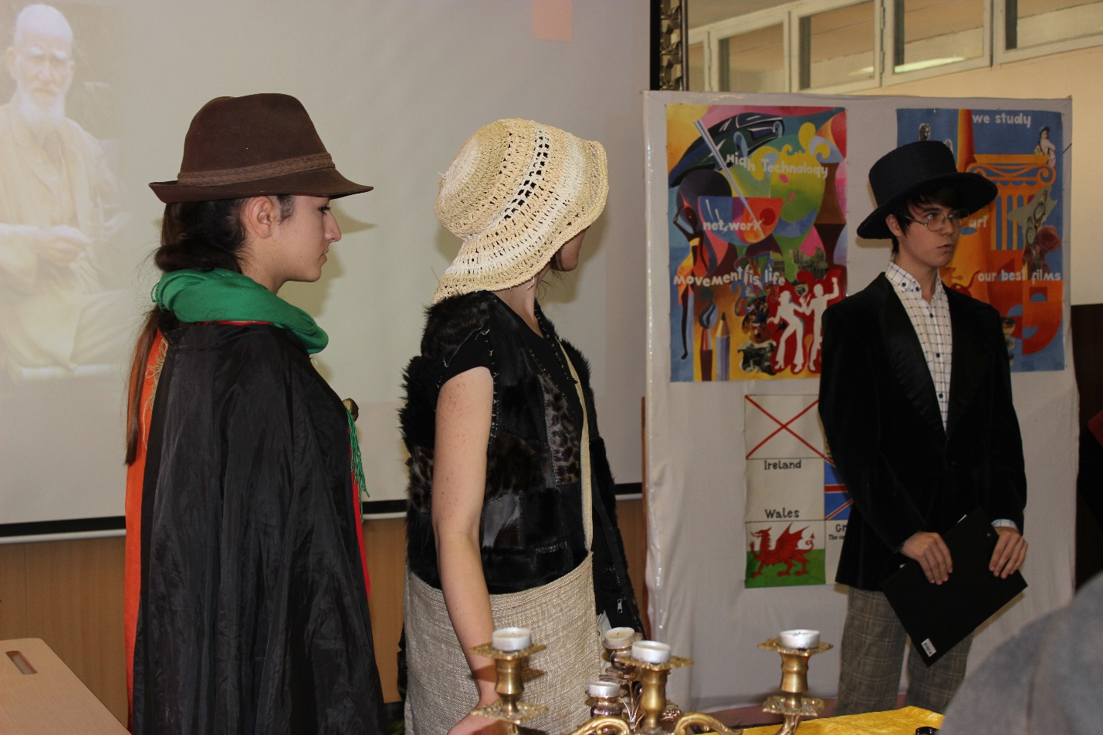
Robinson Crusoe: (слайд 8) Good afternoon, everybody! My book stands next to Gulliver's on the bookshelf. And my author Daniel Defoe as well as Jonathan Swift is considered to be the founder of early bourgeois realism in England. I've spent so much time alone on the deserted island that now I enjoy the company of other literary characters. Here is my best friend - sir Ivanhoe from Walter Scott's novel. Sherlock Holmes: (слайд 10) My name is Sherlock Holmes. They say I am the best detective of all the times. But I don't trust them. You know that I’m fond of checking everything by myself. I’d like to play you the violin but I’m afraid you don't have time for that. (But the comperes plead him to play).
Sherlock Holmes: Oh! Let me introduce the one where my creator Conan Doyle will describe me and Doctor Watson in the story "The Gay Ribbon".
Sir Ivanhoe: (слайд 11) Not bad! Very exciting! Do you want to relax after thriller? Then let’s meet one of the main characters of Bernard Shaw’s play “Pygmalion”, professor Henry Higgins.

Professor Henry Higgins: (слайд 12) Hello, our guests! I will tell you a little about my creator. Did you know that George Bernard Shaw was born in Dublin, Ireland, on the 26th of July 1856? (слайд 13) His family was very poor. Shaw even had to leave school at the age of 15. His family later moved to London. Shaw tried to make a living by writing. There, he started writing novels and plays. He was an outstanding Irish play writer and critic. Bernard Shaw wrote over twenty plays, both tragedies and comedies. In 1934 he was awarded the Nobel Prize for Literature.

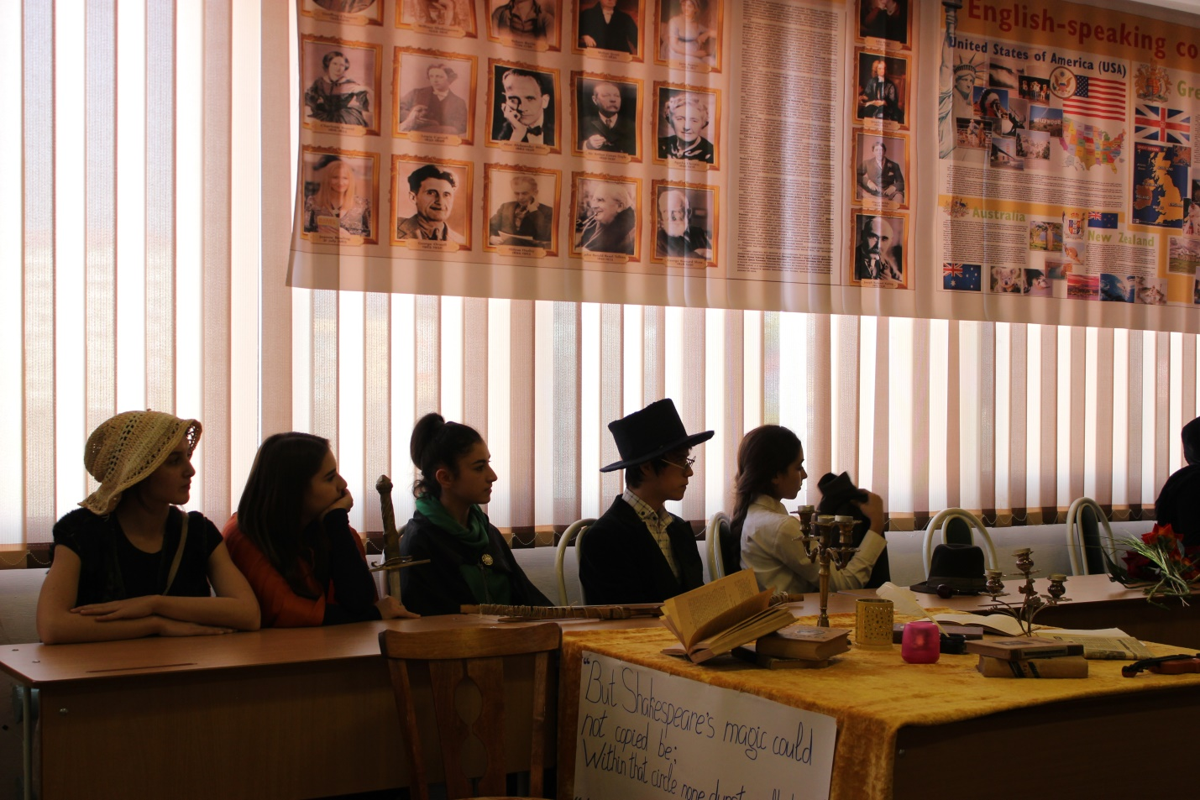
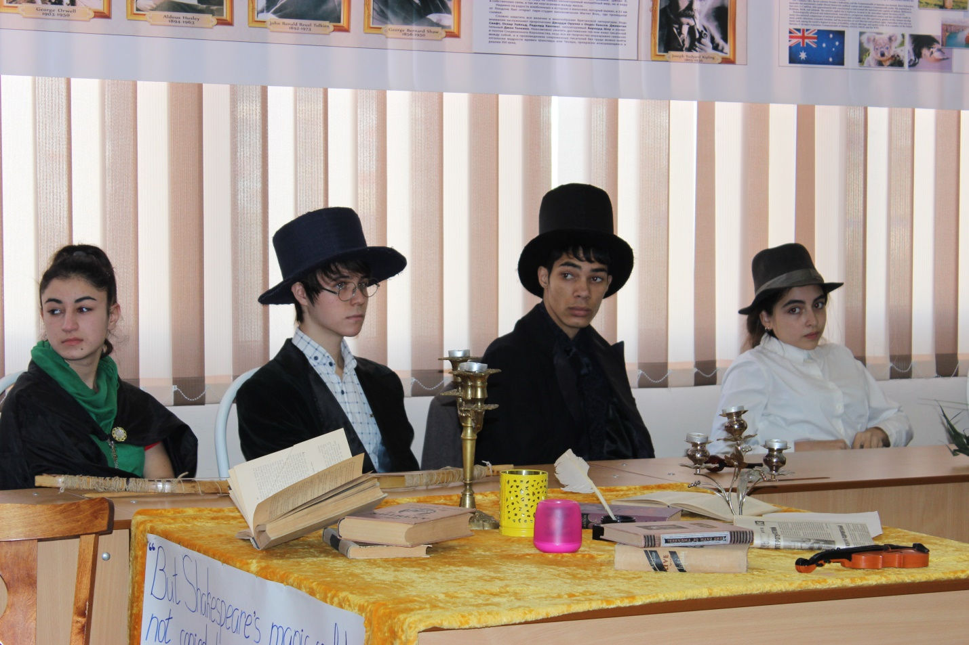
Alice: (слайд 14) Not only children but grown-ups read and enjoy Alice’s adventures in Wonderland by Lewis Carroll. Now meet the main character of this story.
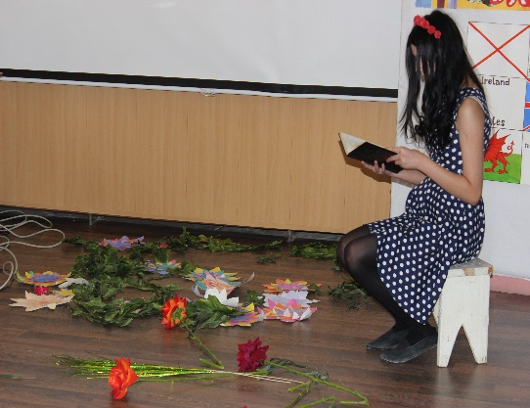
(открывается занавес. Алиса сидит на стуле с книгой в руках, читает, заучивает)
Humpty-Dumpty sat on the wall
Humpty-Dumpty had a great fall
All the king’s horses and all the king’s men
Couldn’t put Humpty
(путается в словах)
Humpty-Dumpty…
Couldn’t put Humpty-Dumpty together again.
( Алиса роняет книгу, раскачивается на стуле. Встает. Выходит в сад-цветник (слайд 15- «Вальс цветов» ).

“Alice in Wonderland”
(звучит дуэт скрипки и флейты. Алиса попадает в сад -цветник. Цветы ( 4 студентки, одетые в костюмы цветов)“слушают”, начинают “танцевать”. В танец вовлекается Алиса. Она оглядывается, пытается пощупать листья).
(слайд 16 видео без звука)
Rose: What an ugly flower!
Flowers: Ugly, ugly.
Rose: She has two stems!
Flowers: Awful, unbelievable! Oh, awful, I’m going to faint! She has no leaves, she has no petals!
Alice: Wow, it can’t be true! Flowers can’t speak!
Rose: But we can, my dear.
Flower 1: If there is someone to talk to.
Flower 2: And if there is something to talk about.
Flower 3: Oh, it’s so exciting, I’m going to faint.
Flowers: And we can sing too!
Alice: (делая реверансы): Oh, please, please, sing, sing!
Rose: Oh, she is sweet. (К цветам): Do sing!
(слайд 16)
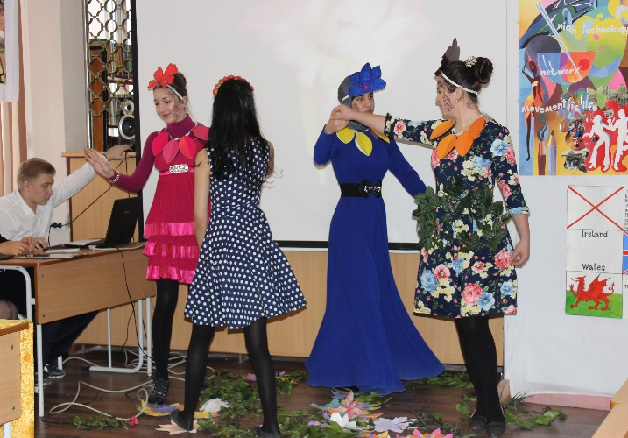
(Вначале громко – распевка, затем пруглушенно, студентки поют под видео)

Flowers’ song
When trees are green and forests are green,
And grass is green and long,
It’s good to walk in the forests
And listen to little bird’s song.
When trees are white and forests are white.
Because they are covered with snow,
It’s good to be out-of-doors and play
Oh, I love it so. (и цветы, танцуя удаляются)
Martin Eden: (слайд 18) Dear ladies and gentlemen! I am Martin Eden. Today you have a real chance to meet one of the most popular American writers- Mr. Jack London.
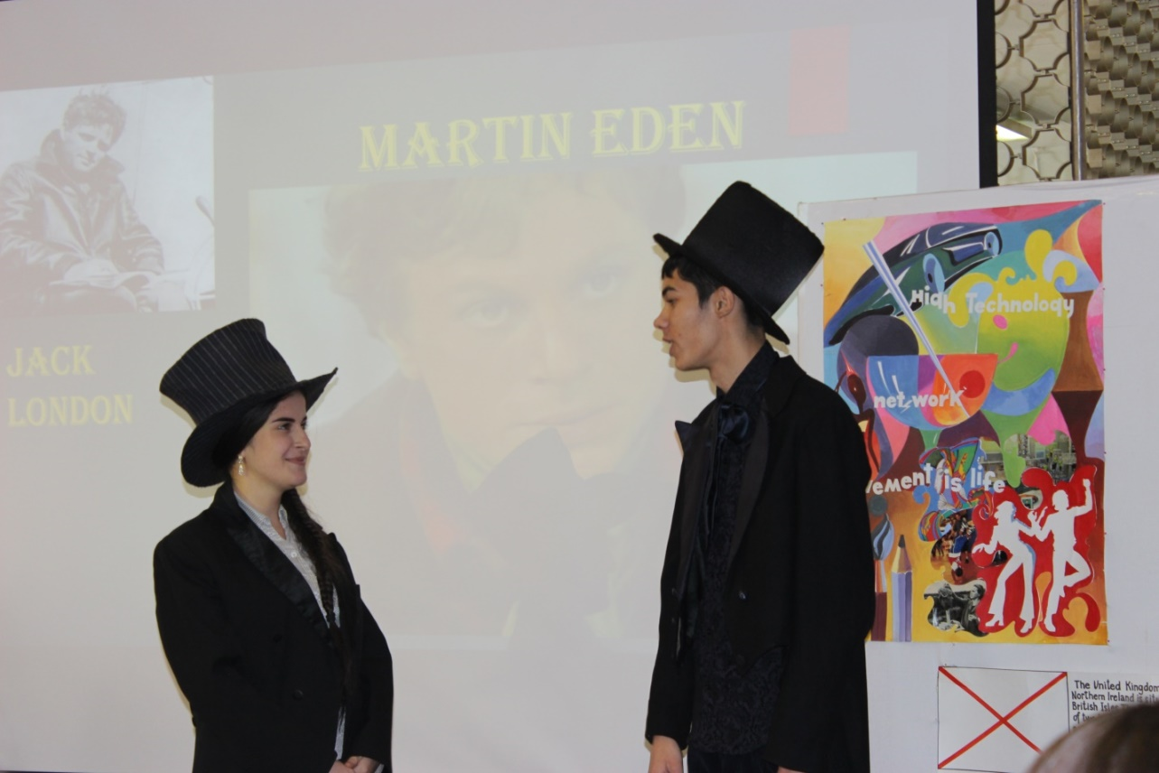
Jack London: Hello, everybody! I am very happy to be here in Daghestan! Thanks for your invitation.
Martin Eden: Mr. London, thank you for coming here. It’s great to see you in our town because we are going to perform our guests two scenes from your novel “Martin Eden” and “White Fang”. Jack London: Oh, I am so pleased. Thank you for your attention to my works. I never would have thought that in a hundred years my books would be so popular.
Compere 1: In the scene from “Martin Eden” you will see the main hero whose prototype was Jack London himself. Martin Eden, a strong man and a talented worker, belongs to a working-class family. He meets Ruth Morse, a girl from a rich family, and falls in love with her. Martin decides to become her equal in knowledge and culture. He must take a career for himself and become a famous writer. He begins to read and study. Ruth helps him.
A scene from “Martin Eden”
(слайд 19- под приглушенную музыку)
Martin: Hello, Ruth.
Ruth: Hello, Martin. Come is, please.
Martin: I’ve bought your books back. Thank you.
Ruth: Oh, that’s nice. Sit down and let’s have a talk. Did you like them?
Martin: Oh, yes. They were good. I like the books on economy, politics and industry. But there were too many new words that I had to use a dictionary.
Ruth: I see. Did you like poetry?
Martin: The poetry was much easier for me. I love poetry and beauty. I find beauty in poetry as I find it in music.
Ruth: What are you going to do next?
Martin: I’m going to read a lot of books and start writing.
Ruth: I think you should go back and finish grammar school, and then go through the high school and university. 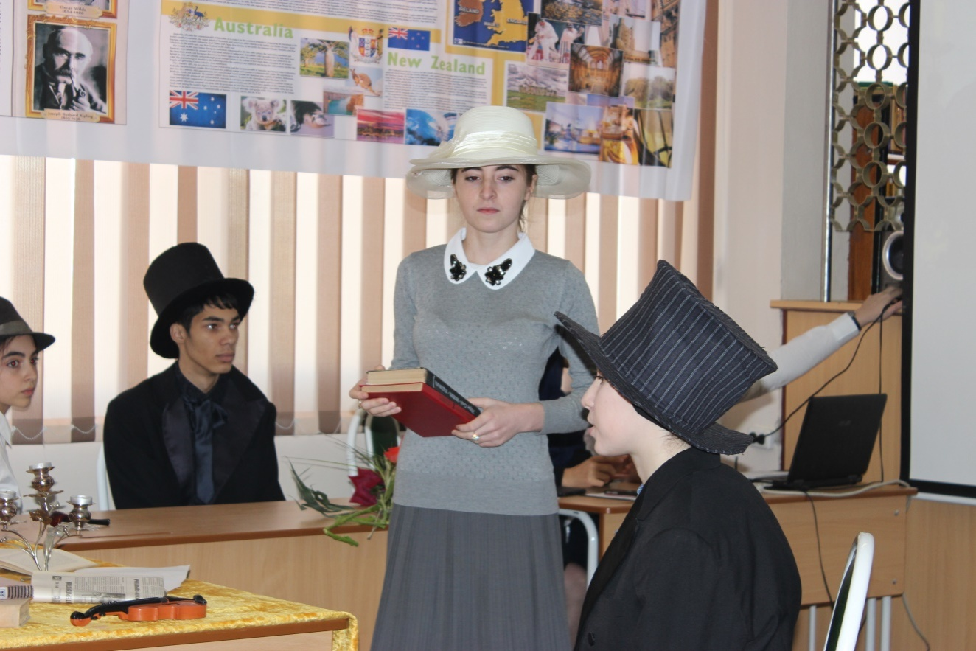
Compere 2: And this is a scene from “White Fang” (слайд 20 –под вой волков).
(слайд 21- видео под приглушенный звук).
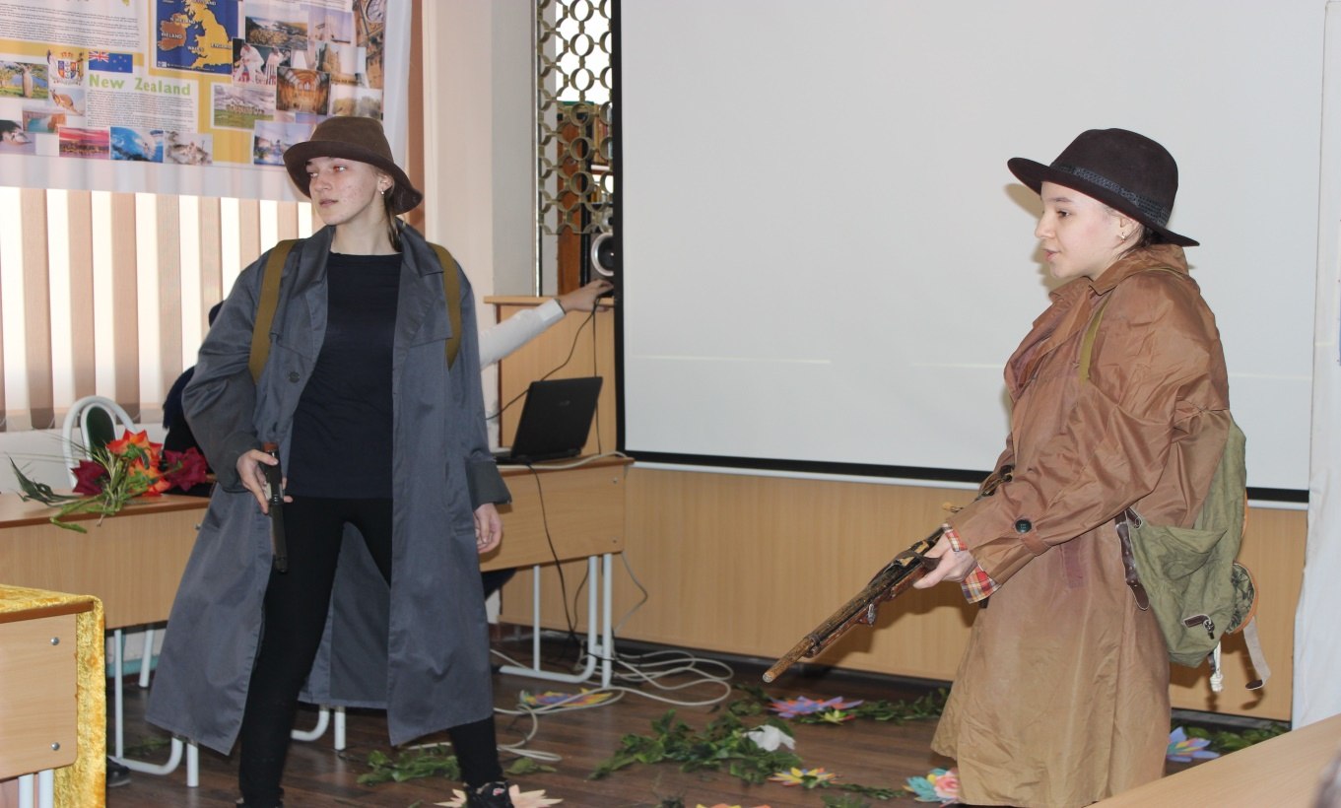
Henry: They are after us, Bill.
Bill: Yes, meat is scarce. I didn’t seen a rabbit sign for days.
Henry: They will follow us.
Bill: Seems to me, Henry, they are staying remarkable close to camp.
Henry: They know where their hides is safe. They would sooner eat grub than be grub. They are pretty wise, then dogs.
Bill: (shaking his head): Oh, I don’t know.
Compere 2: (слайд 22) How do you like it? To my mind it’s time to begin speaking about the authors who wrote the books in which the following characters appear.
Compere 1: Let’s look at the anthology of English poetry, and get acquainted with the authors and their works in the original language and the poetic translation. Compere 2: (слайд 23) It is impossible not to mention W. Shakespeare and many of his immortal poetic works and plays. He was the man with a large and most comprehensive soul. People all over the world can’t help admiring his great talent. Now we offer you his biography and a fragment of one of his works. Student 1: (слайд 24) William Shakespeare, the brilliant poet, the marvelous dramatist, the greatest of the great. He was not of an age, but for all time.
William Shakespeare was born in 1564, on April 23rd in the town of Stratford-on-Avon. He is really one of the greatest writers of all time, and has remained popular with readers around the world. (слайд 25) In his childhood, William probably attended the Stratford Grammar school.
Shakespeare began to write plays for the Globe Theatre.(слайд 26) He was also an actor. During the last years of his life, Shakespeare wrote less and less. In 1613, after the Globe, had been destroyed by the fire, he returned to Stratford and stopped writing altogether.(слайд 27) In April 1616, he died and was buried in the same church, where he was christened.
Compere 1: He was a great poet, but not the only one; a great dramatist, but not the only one; he was a learned man, but not the only one. (слайд 28) He wrote three types of plays: comedies, tragedies and histories. He also wrote narrative poems, sonnets and lyric poetry. He is really one of the greatest writers of all time, and has remained popular with readers around the world. (слайд 29) “Romeo and Juliet” is one of the most popular and frequently produced plays. It is a true masterpiece.
Compere 2: (слайд 30-видео, музыка приглушена) And this is a story about two teen-aged lovers whose families hate each other. Many years ago two families Montekki and Capuletti lived in Verona and behaved each other like enemies. This story is about great love. At a ball the two young people meet and fall in love. The next day they marry secretly, but Romeo has to leave Verona after he kills Tybalt, Juliet’s cousin. Juliet’s father doesn’t know that his daughter is already married and tries to force her to marry her cousin in Paris. A friar wants to help Juliet. He gives her a drug that puts her to sleep for 42 hours and tells everyone that she is dead. When Romeo hears that Juliet has died he hurries to her grave and poisons himself. When Juliet wakes up and sees her dead lover she stabs herself. The two families discover their dead children and end their fight.

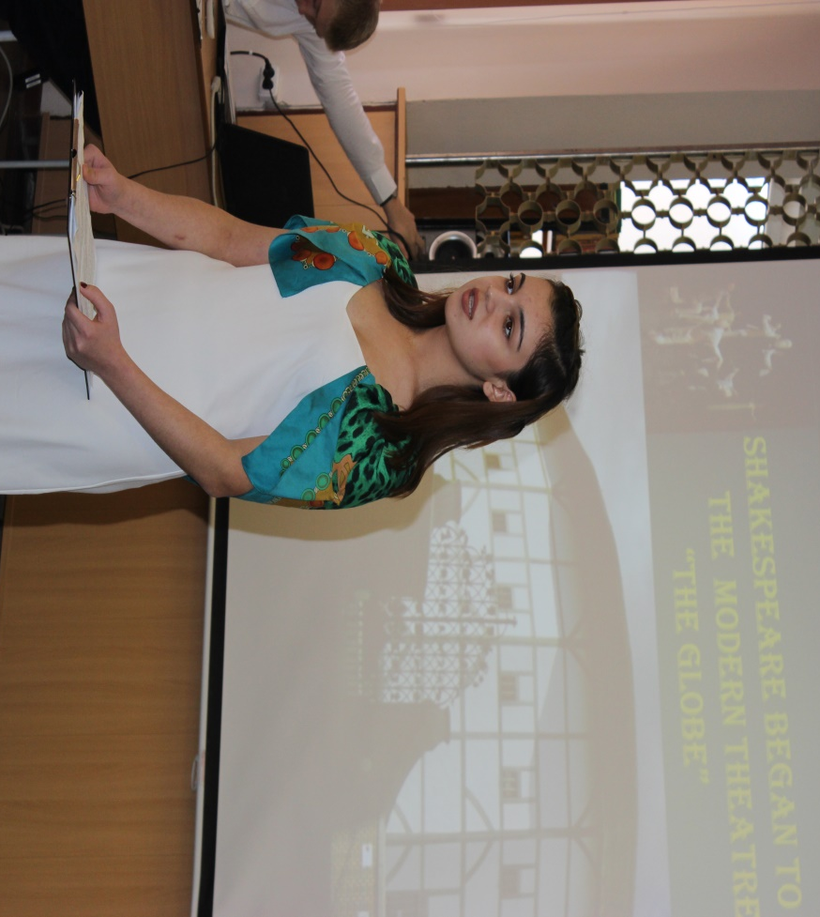

(Слайд 31-видео , музыка приглушена)
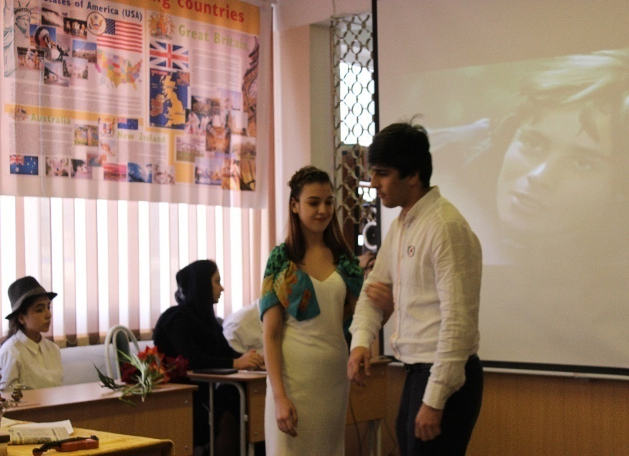
Juliet: Will you be gone? It is not yet near day.
Romeo: I must be gone and live or die if stay.
Juliet: It is time, it’s time for you to go. But time to meet will come again, I know.
Romeo: Good-bye, good-bye. One kiss and I will go. (Ромео убегает)
Juliet: Beward, my husband,
I am afraid you’ll be
Too weak to stay away from me.
So seak for strength, and I will pray
I know,
Soon comes our day.

(звучит песня (слайд 31)“Fragile”. Ромео и Джульетта проходят по сцене, останавливаются, затем, разговаривая, уходят. На мгновение оборачиваются к залу, улыбаются. Джульетта посылает публике воздушный поцелуй. Уходят.)
(слайд 32- музыка звучит громко)
Compere 1: Thank you very much for visiting us! We wish you good luck in your work! And this poet is known all over the world. His popularity in Scotland is very great. The beauty of Scottish wonderful nature, its fields and mountains, large blue sky inspired him. Do you know whom am I speaking about? (Yes, of course, Robert Burns). Welcome to Scotland!
(слайд 33) The greatest poet of the 18th century was Robert Burns. The Scottish bard was born in a clay cottage in the village of Alloway. (слайд 34)
Compere 1: Robert Burns devoted many poems to his lovely Motherland. (слайд 35) Love for Scotland, for the Scottish people and the Scottish language is the main theme of his poems.(слайд 36) In his songs he spoke of what he saw-of the woods and fields and valleys, of the deer and the skylark and the small field-mouse, of the farmer’s poor cottage. Listen to one of his poems, full of colourful description, it’s a hymn to the beauty of Scotland’s nature.
Compere 2: Listen to the poem ‘My hearts in the Highlands’.
(слайд 37-видео, музыка приглашена)
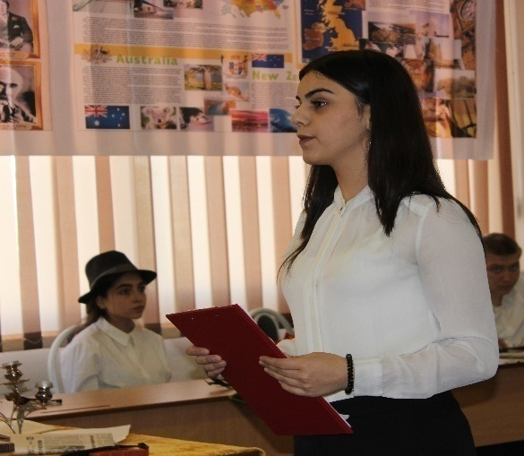
My hearts in the Highlands, my heart is not here,
My hearts in the Highlands a chasing the deer,
A-chasing the wild deer and following the roe-
My hearts in the Highlands, wherever I go.
Farewell to the Highlands, farewell to the North,
The birthplace of valour, the country of worth!
Wherever I wander, wherever I rove,
The hills of the Highlands for ever I love.
Farewell to the mountains high cover’d with snow,
Farewell to the straths and green valleys below,
Farewell to the forests and wild-hanging woods,
Farewell to the torrents and loud-pouring floods!
В горах мое сердце
В горах мое сердце.… Доныне я там,
По следу оленя лечу по скалам.
Гоню я оленя, пугаю козу.
В горах мое сердце, а сам я внизу.
Прощай, моя родина! Север, прощай,-
Отечество славы и доблести край.
По белому свету судьбою гоним,
Навеки останусь я сыном твоим!
Прощайте, вершины под кровлей снегов,
Прощайте, долины и скаты лугов,
Прощайте, поникшие в бездну леса,
Прощайте, потоков лесных голоса.
Student 2: Robert Burns was a remarkable lyric poet. (слайд 38) Love rules over the world. His lyrical poems are known for their beauty, truthfulness, freshness, depth of feelings and their lovely melody. Among his best lyrics is:
“Oh, My Love Is Like a Red, Red Rose”.
Oh, My Love Is Like a Red, Red Rose.
(слайд 39- видео с приглушенной музыкой)
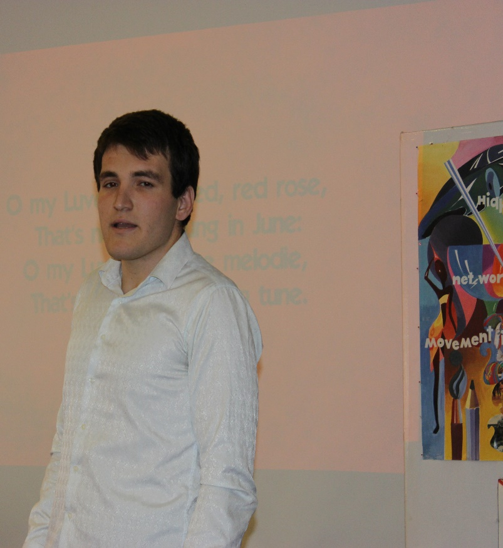
Oh, my Love’s like a red, red rose,
That’s newly sprung in June;
O, my love’s like the melody
That’s sweetly played in tune.
As fair art thou, my bonnie lass,
So deep in love am I,
And I will love thee still, my dear,
Till all the seas go dry.
Till all the seas go dry, my dear,
And the rocks melt with the sun;
I will love thee still, my dear,
While the sands of life shall run.
And fare thee well, my only Love!
And fare thee well a while!
And I will come again, my Love,
Though it were ten thousand mile!
(слайд 40)
Compere 1: Now, I’d like you to read the translation of this poem in Russian.
( слайд 41- видео с приглушенной музыкой)
Любовь, как роза, роза красная.
Любовь, как роза, роза красная
Цветет в моем саду
Любовь моя – как песенка,
С которой в путь иду.
Сильнее красоты твоей
Моя любовь одна
Она с тобой, пока моря
Не высохнут до дна.
Не высохнут моря, мой друг
Не рушится гранит.
Не остановится песок,
О, как же жизнь, бежит.
Будь счастлива, моя любовь,
Прощай и не грусти.
Вернусь к тебе, хоть целый свет
Пришлось бы мне пройти!
Student 3: Robert Burns travelled about Scotland collecting popular songs. After his father’s death he didn’t give up farming and worked hard to earn his living. The last years of his life were very hard. The hard daily work on the farm, the constant starvation and privations finally undermined Burns’s health. On July 21, 1796, at the age of 37, Burns died.( слайд 42) Every year thousands of people from all over the world come there to pay homage to the great poet.
Compere 2: (слайд 43) Our party is dedicated to the greatest American humorist, novelist, and well-known writer Mark Twain. People all over the world can’t help but admire his great humor. He was known as a great humorist.
Student 4: (слайд 44) Mark Twain, whose real name was Samuel Clemens, was born on November 30, in 1835, in Florida, in the small town of Hannibal on the Mississippi River. (слайд 45) His father was a lawyer. When Samuel was 11 years old, his father died. Little Samuel was a bright lovely boy. He went fishing and swimming to the river and he was the leader in all the boys’ games. Samuel had a lot of friends at school. And when he became a writer he described them in his stories.
Compere 2: He visited many countries and lived in England for a long time. In spite of the fact that his life was so difficult, humour helped to take it easy. Here’re some funny episodes from his life. (слайд 46) The most favourite characters are Tom Sawyer, his friend Huckleberry Finn, Becky, his family and his friends. We are going to show you two scenes: “Tom and Aunt Polly”, “Tom doesn’t want to go to school”.
Scene 1 “Tom and Aunt Polly”
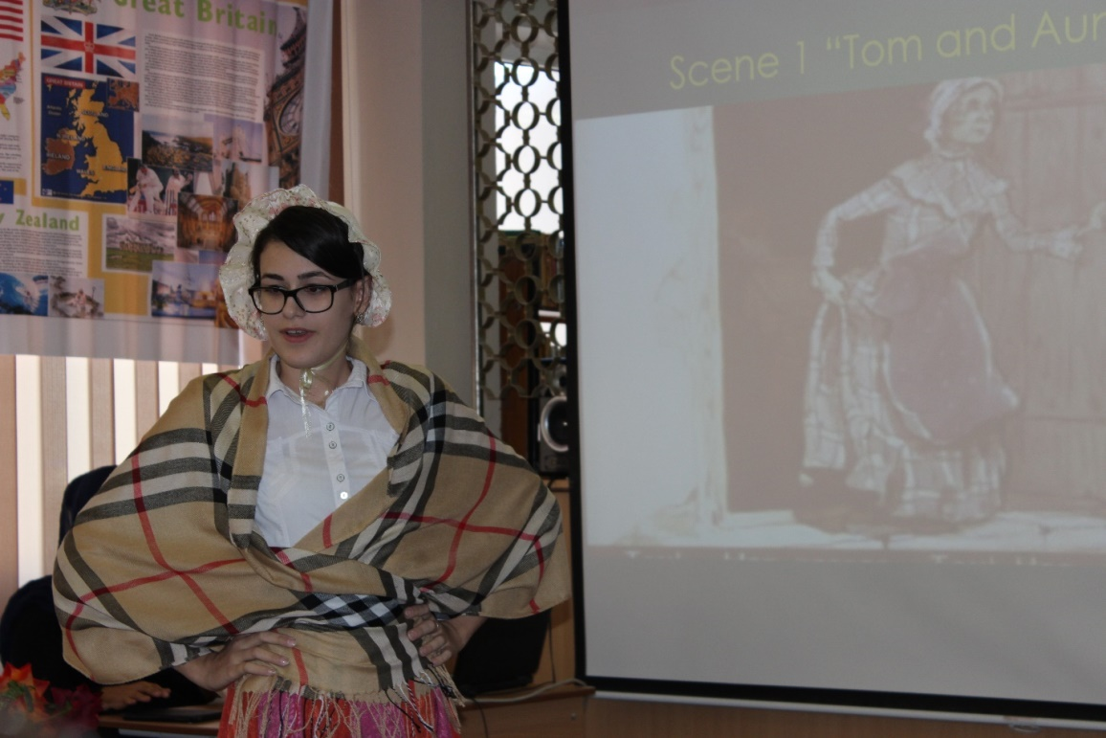
(слайды 47, 48)

(комната Тома. В комнату заходит тетя Полли и зовет племянника). Aunt Polly: Tom! Tom! Where is that boy, I wonder? You, Tom!
(тетушка осматривает комнату, потом громко кричит) : Aunt Polly: Well, if I get hold of toy, I’ll…. (в кладовке что-то зашуршало, тетя обнаружила, что в ней нет Тома) Aunt Polly: There! What have you been doing in there?
Tom: Nothing.
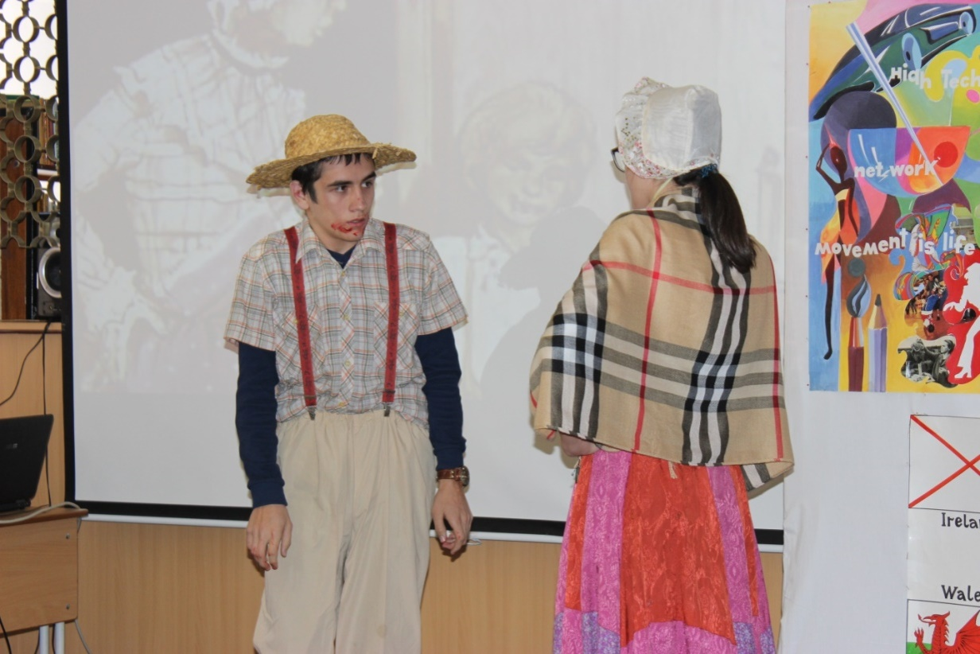
Aunt Polly: Nothing! Look at your hands! And look at your mouth! What is that? Tom: I don’t know, Aunt.
Aunt Polly: Well, I know. It’s jam – that’s what it is. Forty times I’ve said if you didn’t let that jam alone I’d skin you. Hand me that stick. (тетушка Полли берет розги и размахивает ими в воздухе). Tom: Hey! Look behind you, Aunt.
(тетя обернулась, а Том в это время подбежал к двери и сбежал. Тетя постояла некоторое время в растерянности, а потом начала смеяться).
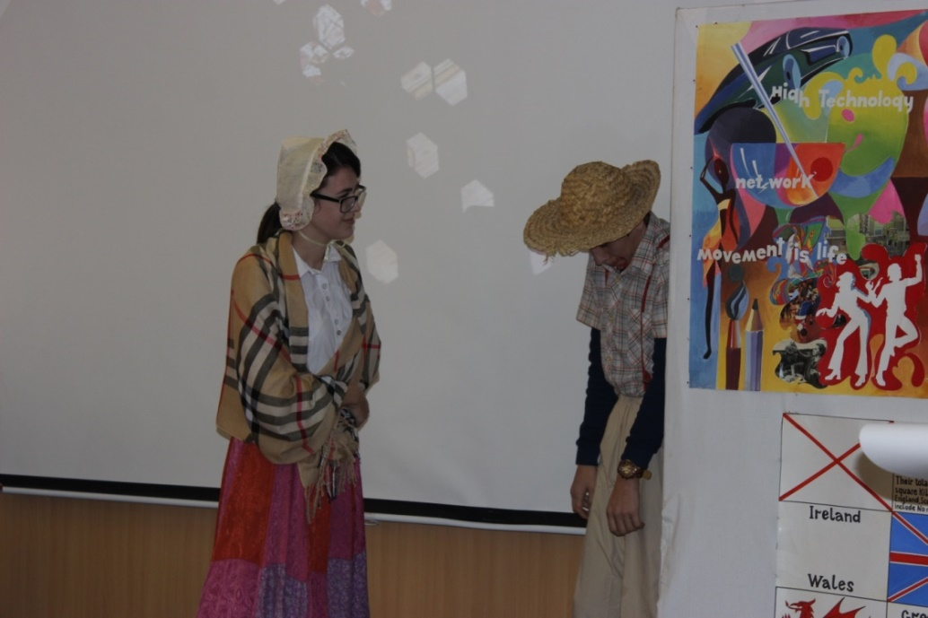
Scene 2 “Tom doesn’t want to go to school”
(слайд 49)
Aunt: What’s the matter, Tom? What’s the matter with you, my child? Tom: Oh, my aunt, I have a terrible toothache! Aunt: Your tooth, indeed! What’s the matter with your tooth? Tom; One of them is loose and it aches me awful. Aunt: Oh, no, don’t begin that groaning again! Open your mouth. Oh, well, your tooth is loose, but you are not going to die over that. Oh, Mary, get me a silk thread! Tom: Oh, Aunty, don’t pull it out. I don’t want to stay home from school. Aunt: Oh, so, all this row because you didn’t want to go to school. Oh, you are breaking my old heart! You are really breaking my old heart! Open your mouth! The dental instrument is ready!
Tom; Oh, no!
(Тетя силой заставляет Тома открыть рот, привязывает веревку к зубу и вырывает его).
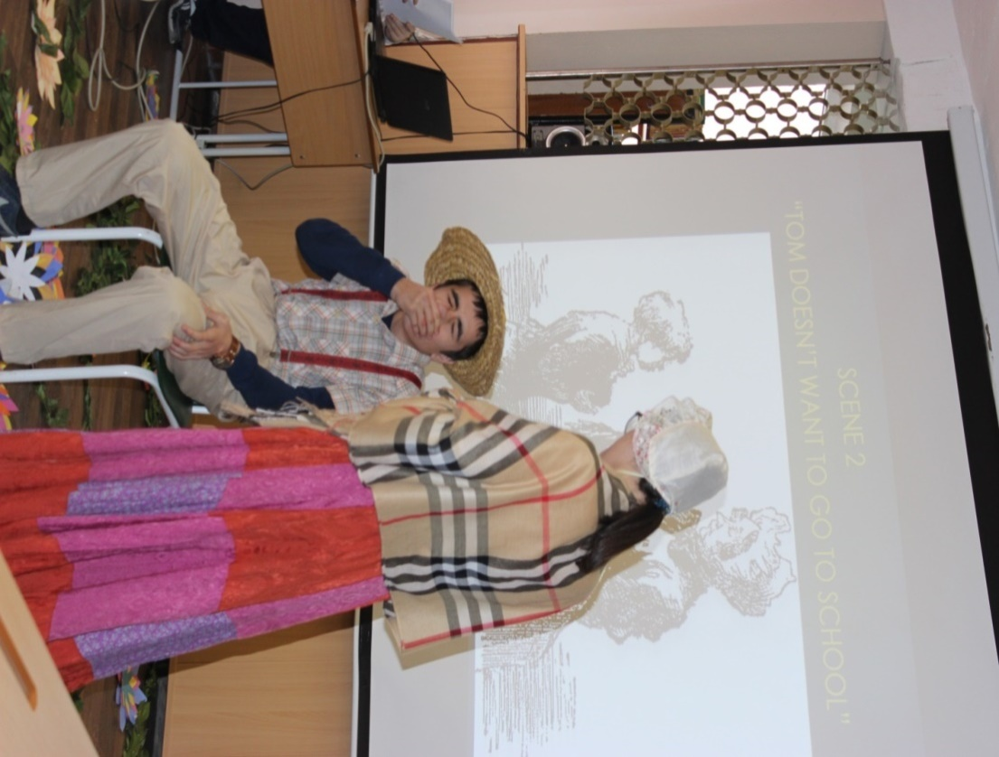

Compere 1: (слайд 50) Well, our party is in progress. Do you know about the greatest English poet of the 18th century? George Gordon Byron. (слайд 51) He was a romanist, who never lost his sense of wonder at the world.
(слайды 52, 53)
There is pleasure in the pathless woods,
There is a rapture on the lonely shore,
There is society, where none intrudes,
By the deep Sea, and Music in its roar:
I love not Man the less, but Nature more,
From these our interviews, in which I steal
From all I may be, or have been before,
To mingle with the Universe, and feel
What I can never express – yet cannot all conceal.

(слайды 54,55, 56)
Есть наслаждение и в дикости лесов,
Есть радость на приморском бреге,
И есть гармония в сем говоре валов,
Дробящихся в пустынном беге.
Я ближнего люблю, но ты, природа-мать,
Для сердца ты всего дороже!
С тобой, владычица. привык я забывать
И то, чем был, как был моложе,
И то, чем ныне стал под холодом годов.
Тобою в чувствах оживаю:
Их выразить душа не знает стройных слов
И как молчать о них – не знаю.
Compere 1: Well done! This poet was loved by many women. (слайд 57) An attractive appearance, excellent education and fantastic talent made George Byron the brightest representative of the English Poetry
Compere 2: As for me, I’m very fond of this person. Do you remember some of his poems? (слайд 58)
She walks in beauty, like the night
Of cloudless climes and starry skies,
And all that’s best of dark and bright
Meet in her aspect and her eyes,
Thus mellowed to that tender light
Which Heaven to gaudy day denies.
One shade the more, one ray the less;
Had half impaired the nameless grace.
Which waves in every raven tress
Or softly lightens’ o’er her face,
Where thoughts serenely sweet express
How pure, how dear their dwelling place.

Compere 1: Thank you! It’s always pleasant to listen to you. ( слайд 59) Now go to Thomas Moore (1799-1852) – an Irish poet and composer of the 18th century, who, while travelling over different countries collected folklore, visited St. Petersburg and was enchanted by the chime of the bells of its churches and monasteries. (слайд 60)
Those Evening Bells
(слайд 61- видео с приглушенным романсом (минусовка))
Those evening bells, those evening bells
How many a tale their music tells.
Of youth and home and that sweet time
When last I heard their soothing chime.
Those joyous hours are passed away;
And many a heart that then was gay,
Within the tomb now darkly dwells,
And hears no more those evening bells.
And so it will be when I am gone:
That tuneful peal will still ring on,
While other bards will walk these dells,
And sing your praise, sweet evening bells.
Вечерний звон
Вечерний звон, вечерний звон!
Как много дум наводит он
О юных днях в краю родном,
Где я любил, где отчий дом,
И как я, с ним навек простясь,
Там слушал звон в последний раз.
Уже не зреть мне светлых дней
Весны обманчивой моей!
И сколько нет теперь в живых
тогда веселых, молодых!
И крепок их могильный сон,
Не слышен им вечерний звон.
Лежать и мне в земле сырой!
Напев унывный надо мной
В долине ветер разнесет;
Другой певец по ней пройдет,
И уж не я, а будет он
В раздумьи петь вечерний звон.
(слайд 62- отрывок из кинофильма «В бой идут одни старики)
Compere 2: (слайд 63) Our party in literature is coming to its end. Finally, listen to the song. (слайд 64)
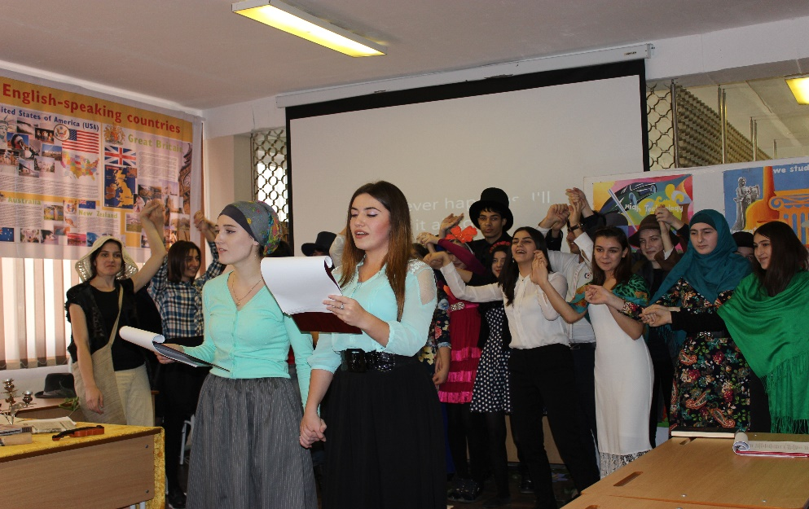
(Участники собираются вместе. Исполняется песня “Show must go on”)

Queen - The Show Must Go On

(слайд 65- песня со словами)
Empty spaces - what are we living for
Abandoned places - I guess we know the score
On and on, does anybody know what we are looking for...
Another hero, another mindless crime
Behind the curtain, in the pantomime
Hold the line, does anybody want to take it anymore
The show must go on
The show must go on, yeah
Inside my heart is breaking
My make-up may be flaking
But my smile still stays on
Whatever happens, I'll leave it all to chance
Another heartache, another failed romance
On and on, does anybody know what we are living for ?
I guess I'm learning (I'm learning learning learning)
I must be warmer now
I'll soon be turning (turning turning turning)
Round the corner now
Outside the dawn is breaking
But inside in the dark I'm aching to be free
The show must go on
The show must go on, yeah yeah
Ooh, inside my heart is breaking
My make-up may be flaking
But my smile still stays on
Yeah yeah, whoa wo oh oh

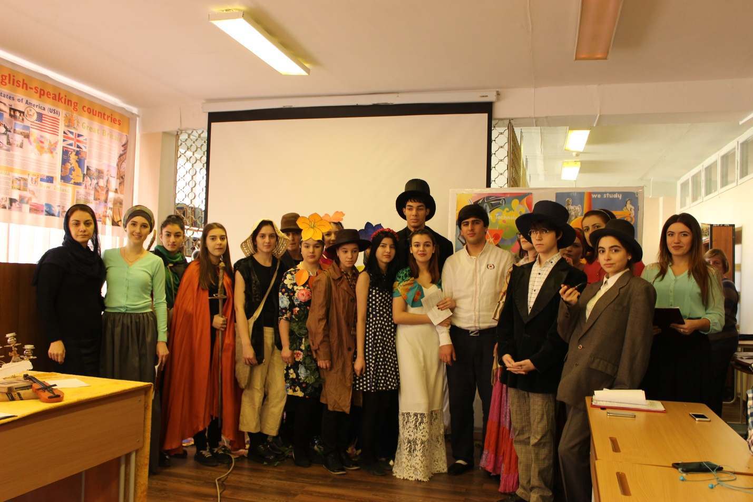

Teacher: Dear, guests! Out party is over. I want to thank our students for their activity they have done today.

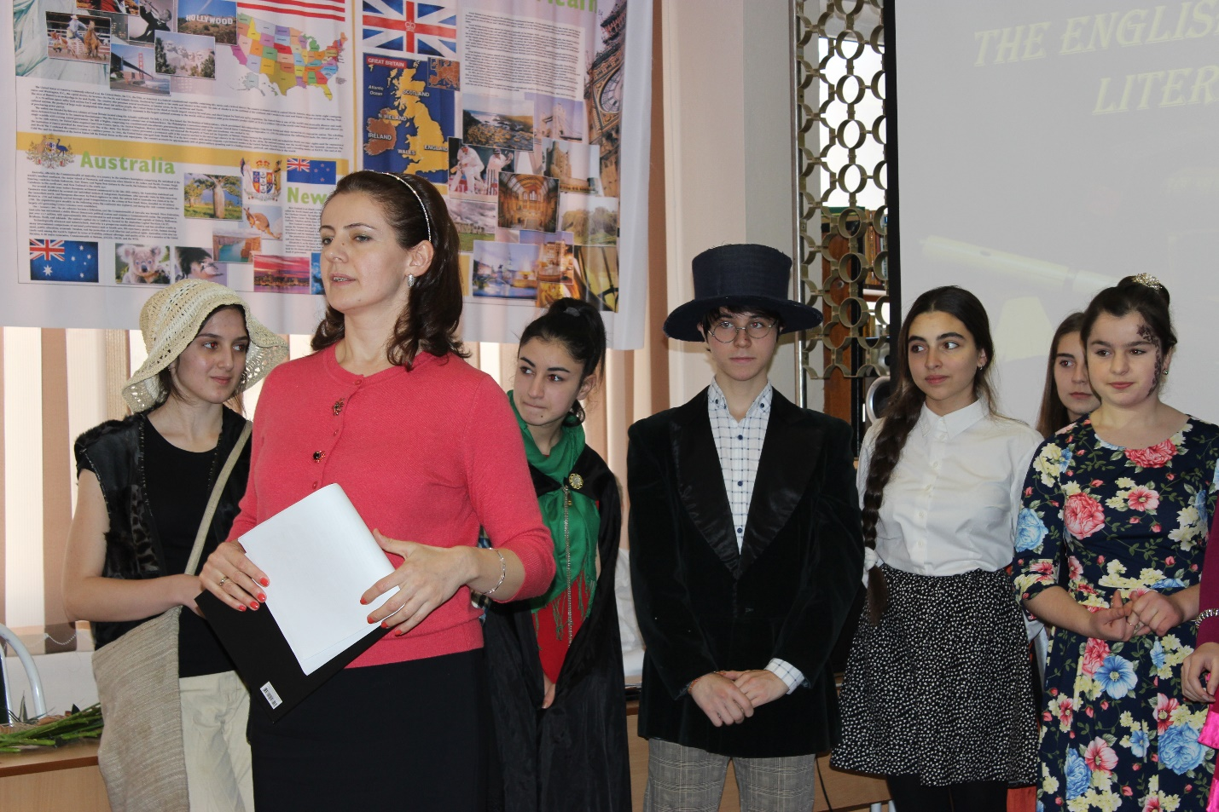
Raise your head!
Jump up high!
Wave your hand
And say “Good-bye”!

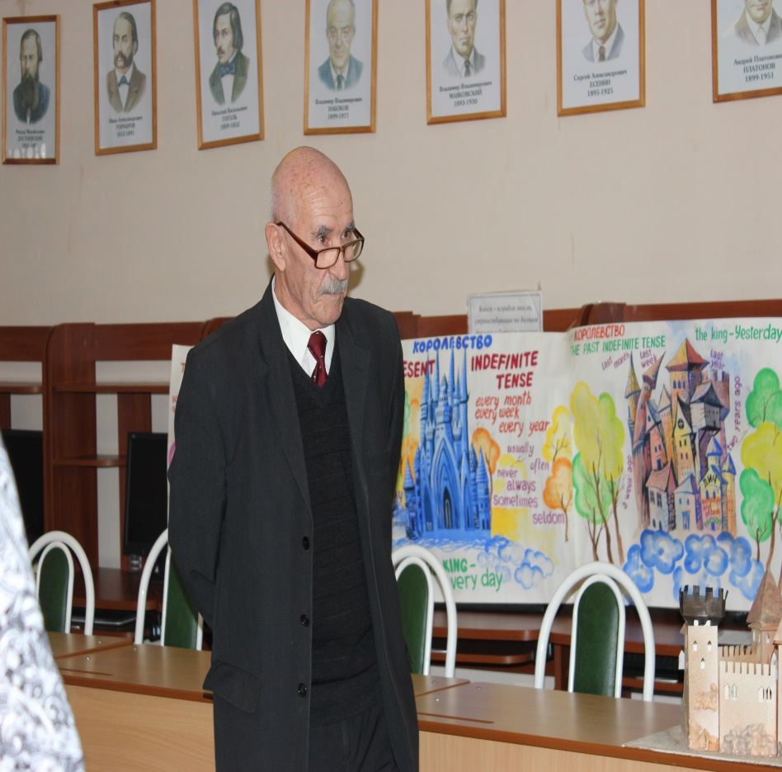
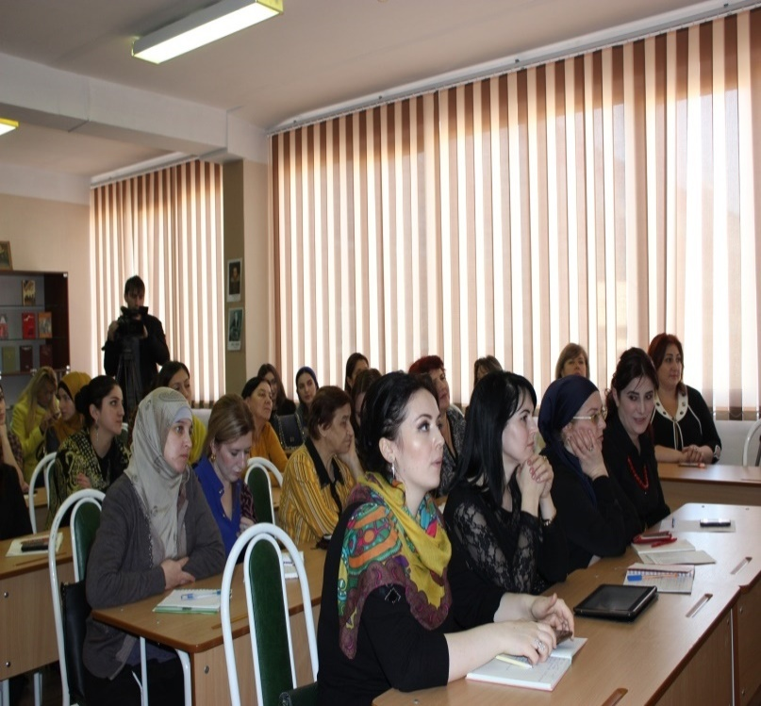
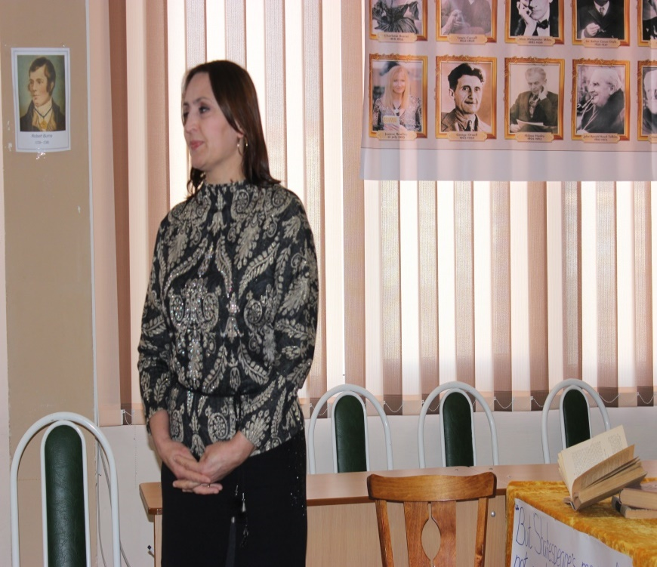

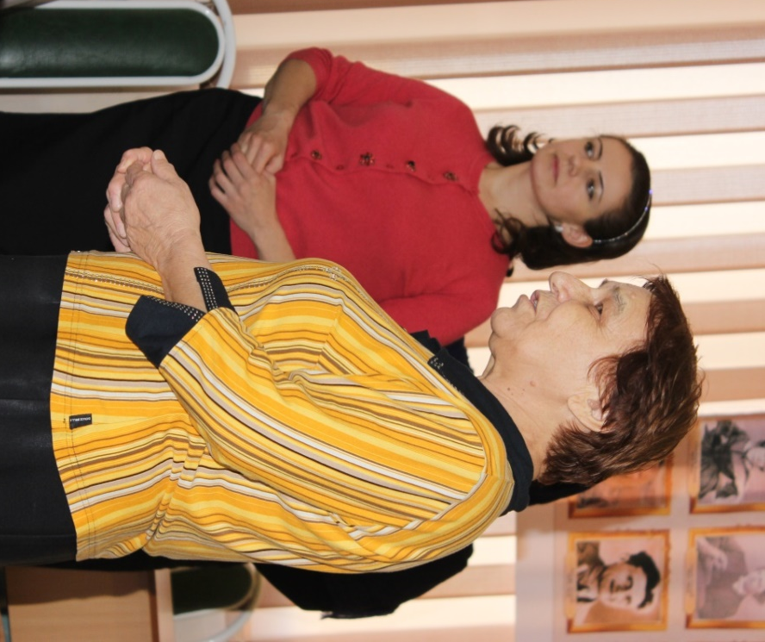
And we hope our party impressed you. We’ll be glad to see you again. Be healthy and wealthy! Thank you ever so much. Have a nice day!

Список использованной литературы
1.Афанасьева О.В., Бартош Д.К. Научно-методический журнал «иностранные языки в школе» №2. М.,2012г.
2. Громушкина А., Соловейчик А. Английский язык, приложение к «Первое сентября», №4. М., 2014г.
3. Ерхова Е.Л., Захаркина С.В. Английский язык. 5-11 кл.: театрально-языковая деятельность: технология, сценарии спектаклей. «Учитель», Волгоград, 2009г.
4. Соловейчик А. Английский язык, приложение к «Первое сентября», №5-6, 2014г.
Интернет-ресурсы
http://englishstory.ru/jack-london-in-english.html
http://englishstory.ru/angltyskie-pisateli

